**User manual**

**for**



**An Excel-based tool for calculating the coupling coordination degree from the cosine of the high-dimensional spatial angle perspective**

**Software availability**

**Name of software:** Ex-CCD, Version 1.0.

**Developers:** Dehui Bian (201931180020@mail.bnu.edu.com) and Shan Liu.

**Year first available:** 2022.

**Hardware requirements:** PC.

**Supported systems:** Microsoft Windows, macOS.

**Program language:** VBA for Excel©.

**Availability:** https://doi.org/---------.

January 2022

**1.** **Overview of the model proposed and Ex-CCD**

The coupling coordination degree (CCD) is an important yardstick for sustainable development. In recent years, research on the CCD has gradually become a hot spot in the area of sustainable development. However, the existing CCD models have inherent shortcomings. Currently, no consensus has been reached on the models. In line with this background, this research proposes a new CCD model from the perspective of the cosine of the high-dimensional spatial angle and develops a novel Excel© tool named Ex-CCD. Ex-CCD is a user-centered design (UCD). Moreover, the user interface of the Ex-CCD tool arranges the design of the input and output interfaces very well, and the Ex-CCD tool also includes an operating system with a certain and clear process.

It is hoped that the proposed model and the tool developed for calculating the coupling coordination degree in this research can be widely used in the future.

**2. Ex-CCD download**

You can download the tool from our paper titled *Ex-CCD: An Excel-based tool for calculating the coupling coordination degree from the cosine of the high-dimensional spatial angle perspective*.

**3. Ex-CCD operation steps**

*3.1. Tool start*

Double-click the tool file  with the left mouse button to start Ex-CCD.

*3.2. Tool interface*

The main interface of the tool is shown in the figure below.

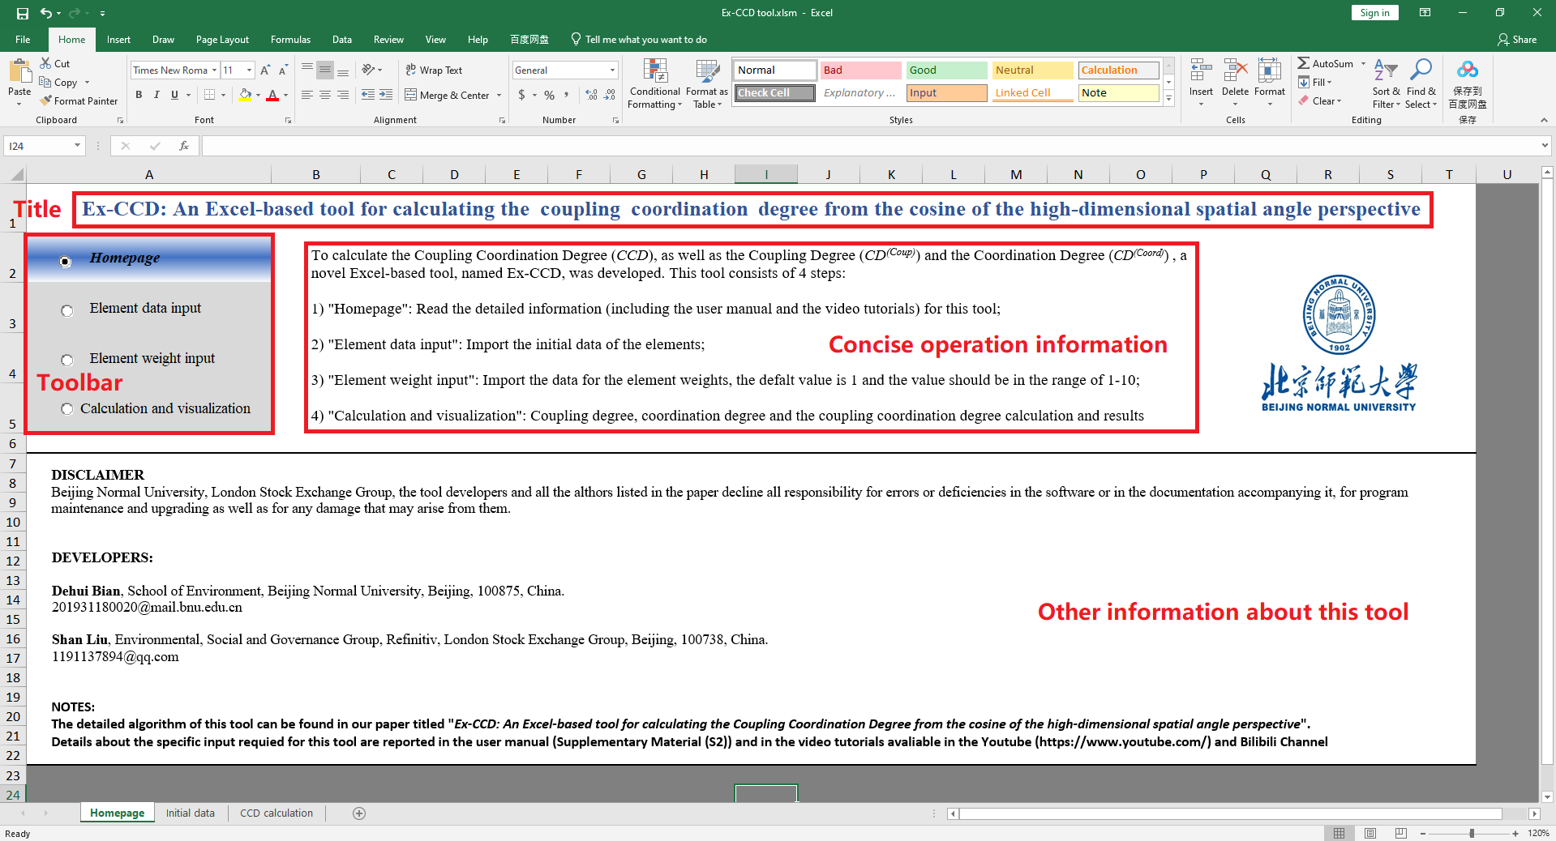

*3.3. Element data input*

Click the “Element data input” button in the figure below to enter the element data value.

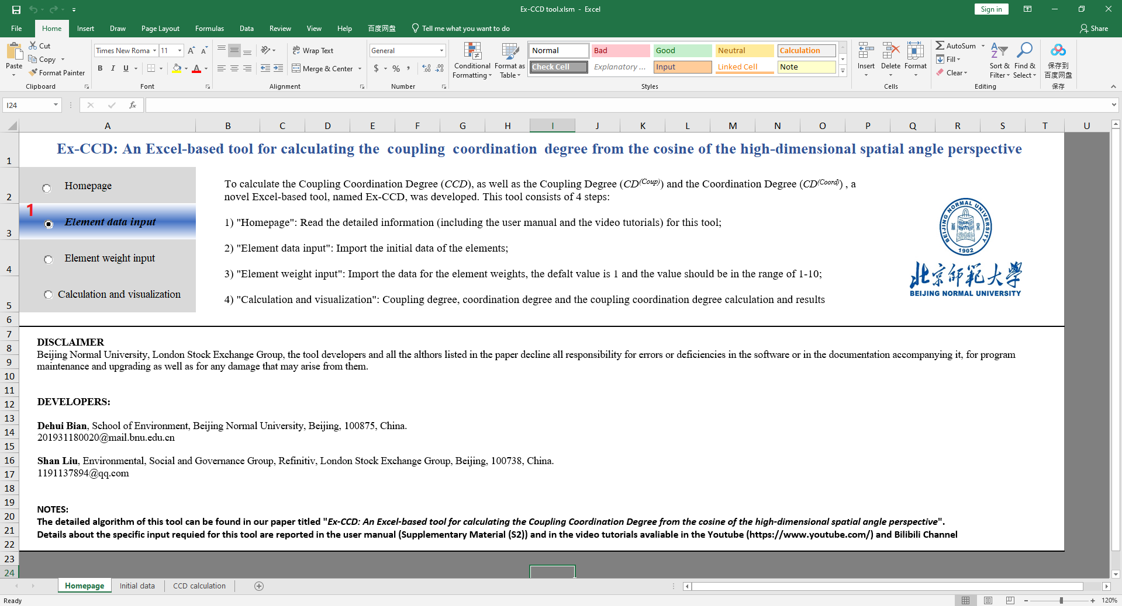

Enter the data manually or copy it from another location and paste it over in the red box. Then, click the “Back” button to return to the main interface of the tool.

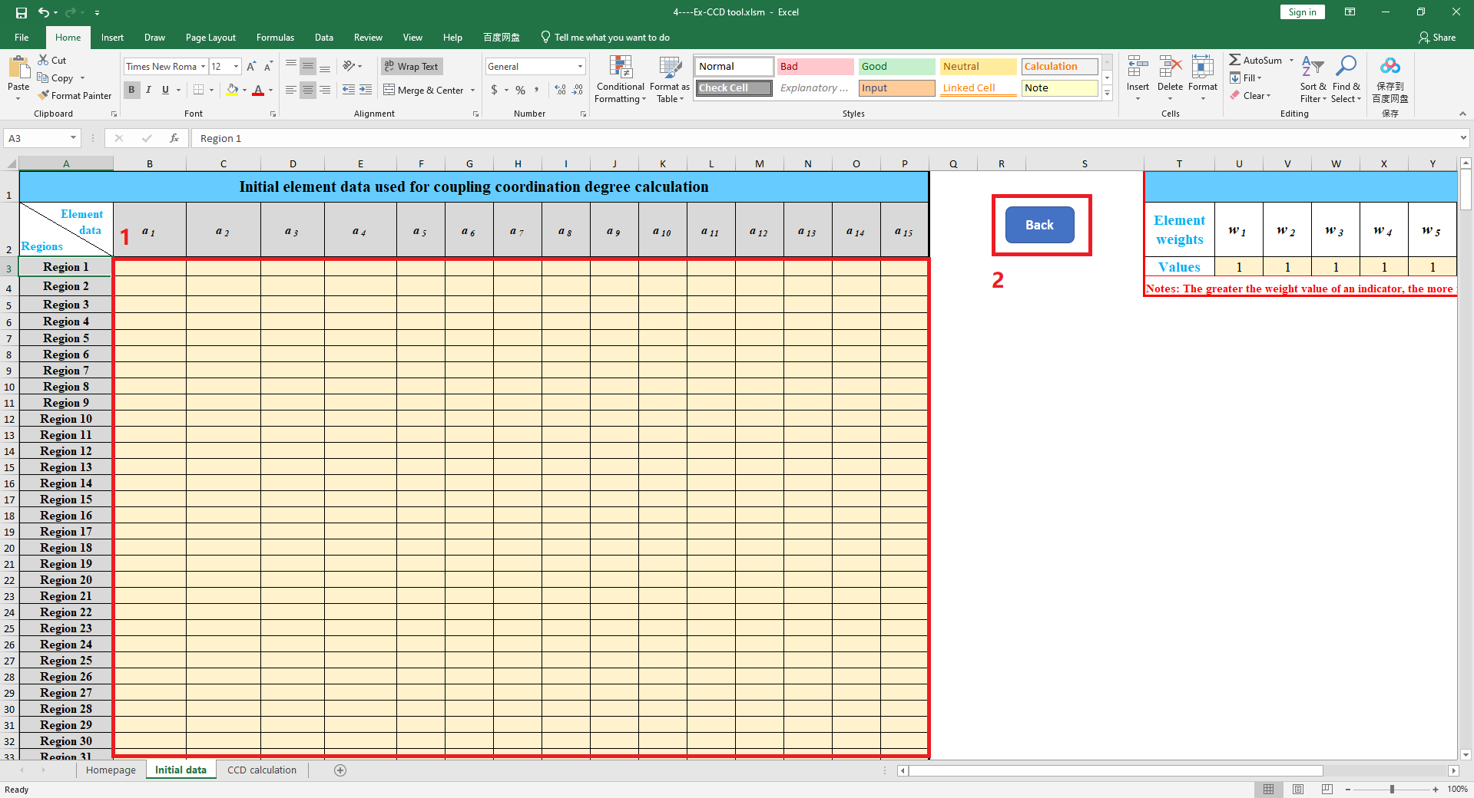

We use the data shown in the figure below as sample data.

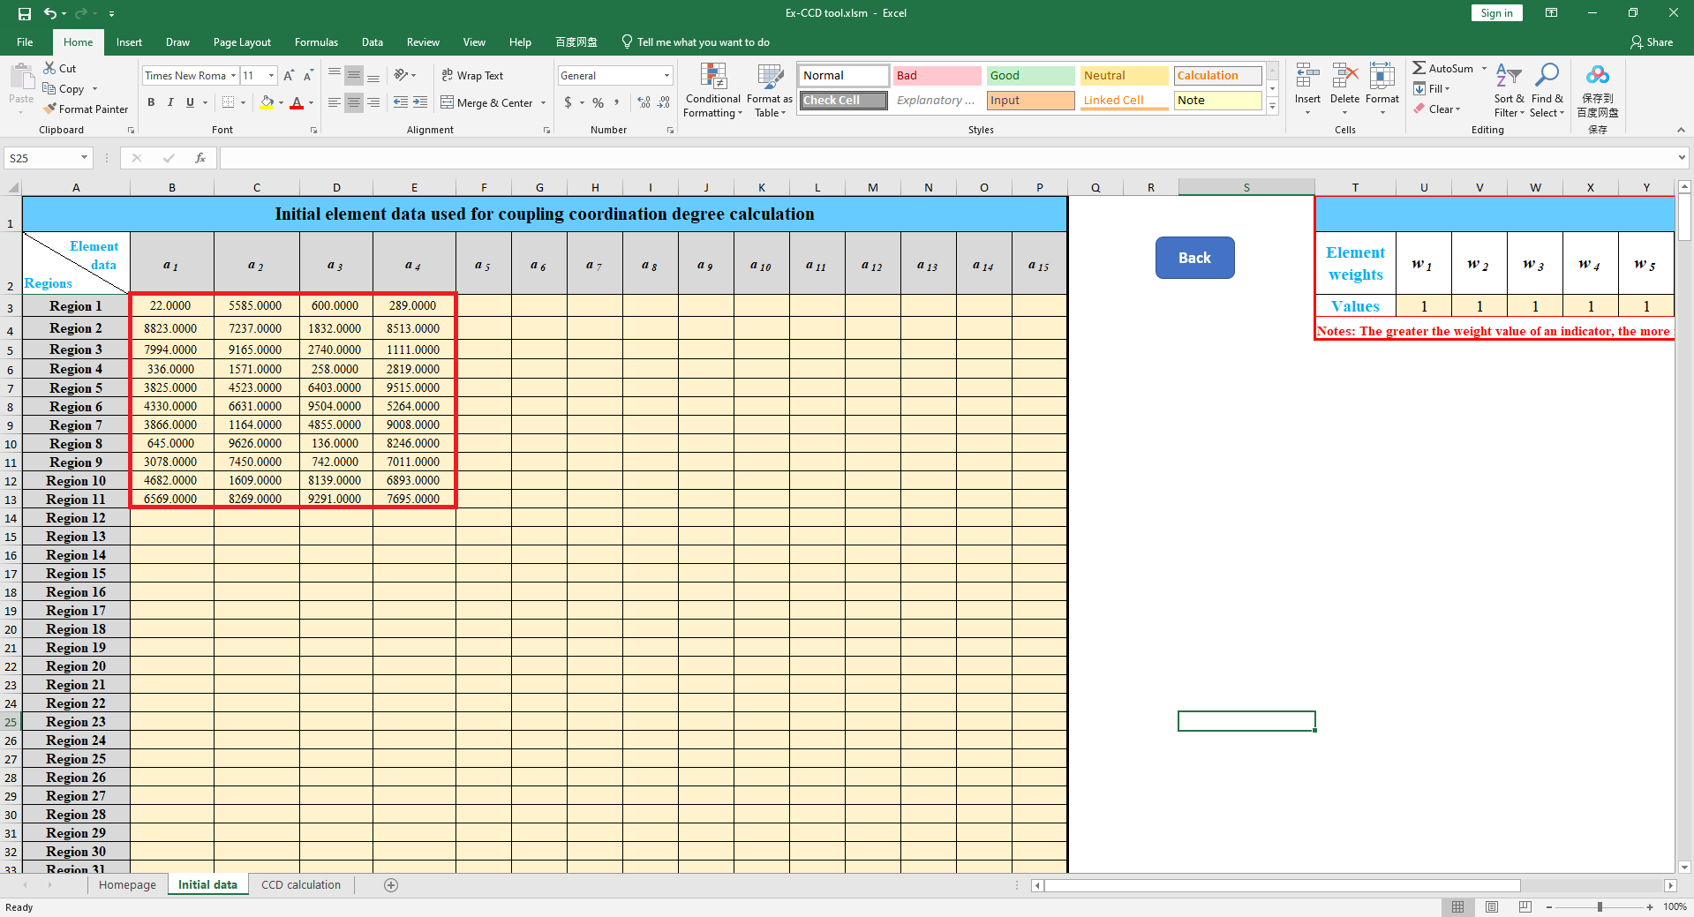

*3.4. Element weight input*

Click the “Element weight input” button to enter the element weights.

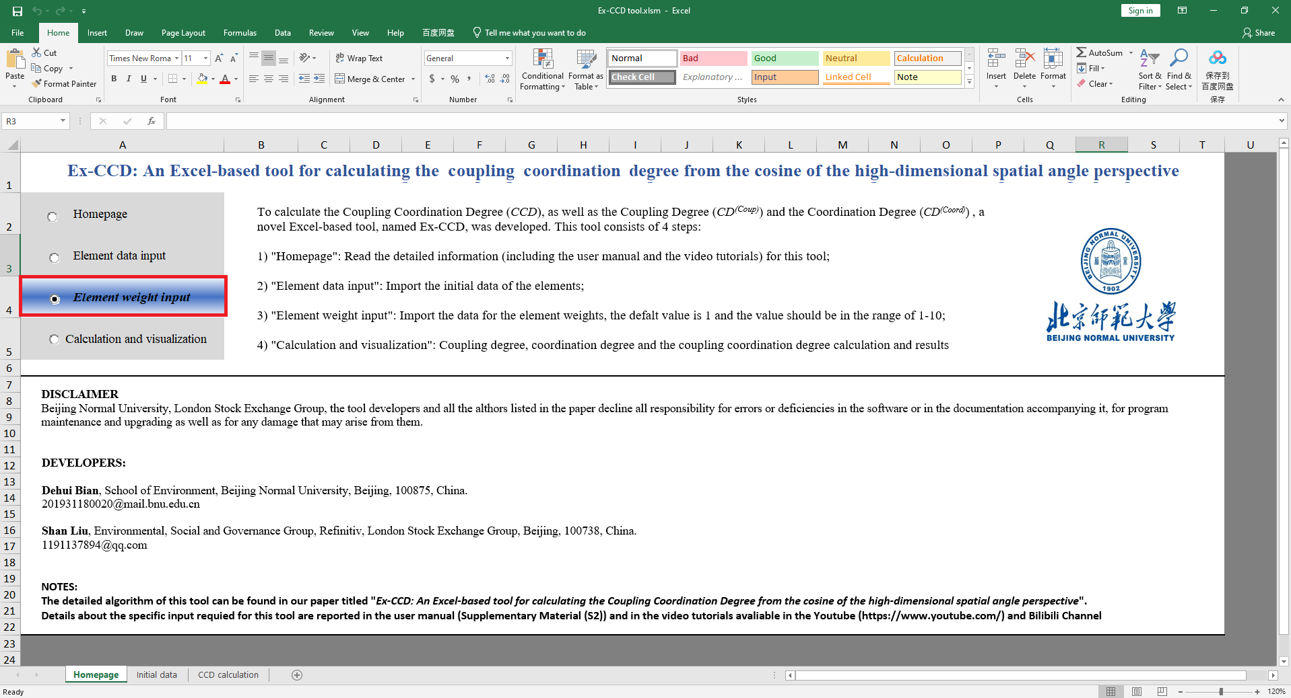

After entering the element weights, click the “Back” button to return to the main interface of the tool.

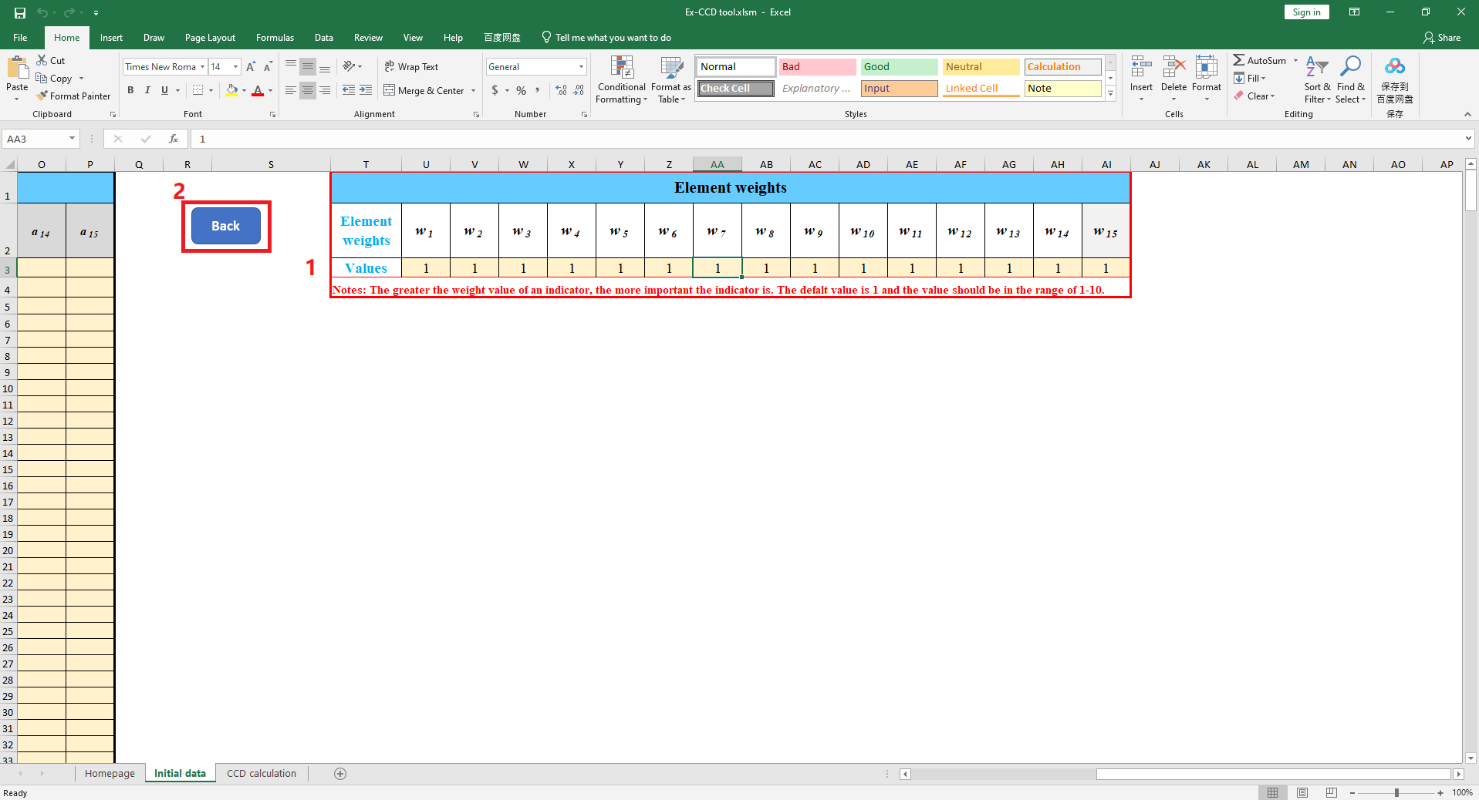

*3.5. Calculation and visualization*

Then, click the “Calculation and visualization” button to go to the next step.

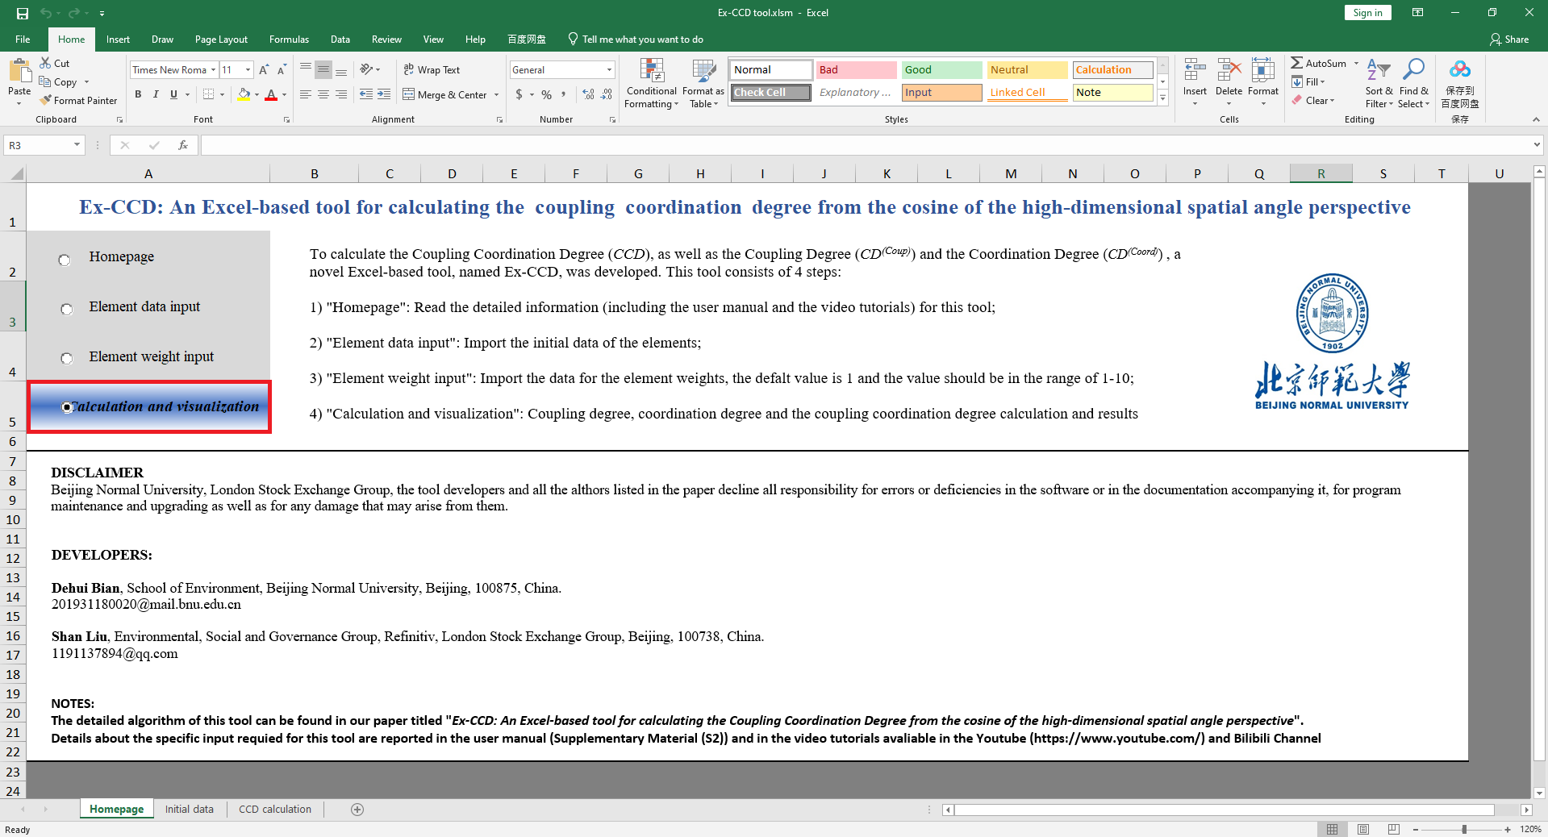

After clicking the “Calculation and visualization” button, the tool will verify the basic information of the submitted data and execute the program.

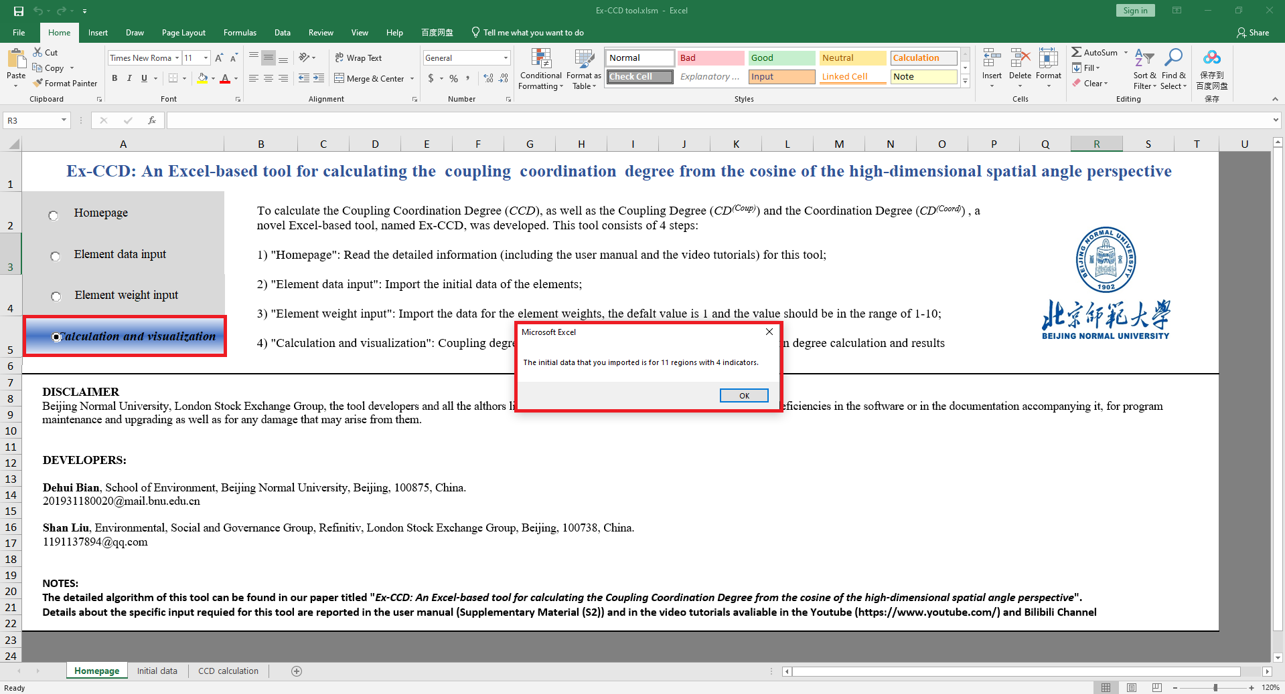

Once the calculation and visualization have been completed, a message saying “Calculation complete” will be shown.

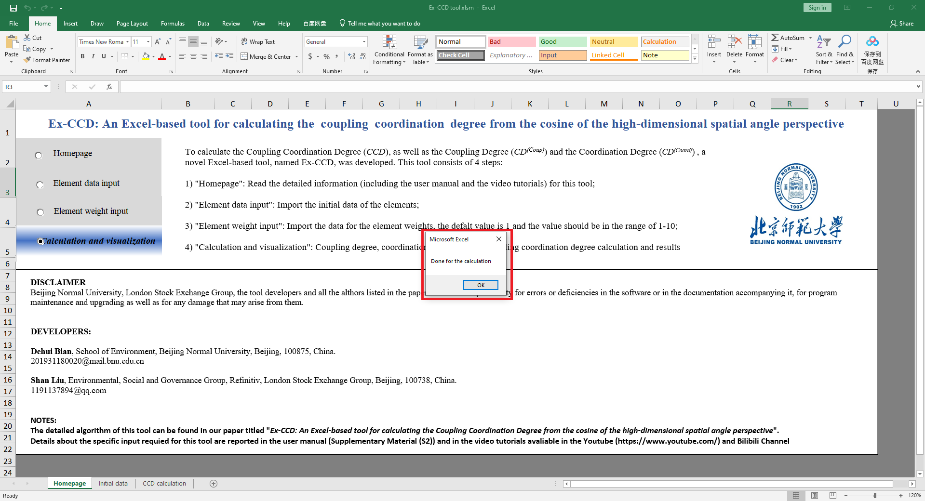

The tool will automatically display the resulting interface. The resulting interface includes 1) the multiple results of the standardized element data and the element weights; 2) coupling degree, coordination degree, and coupling coordination degree; and 3) a visualization of the results.

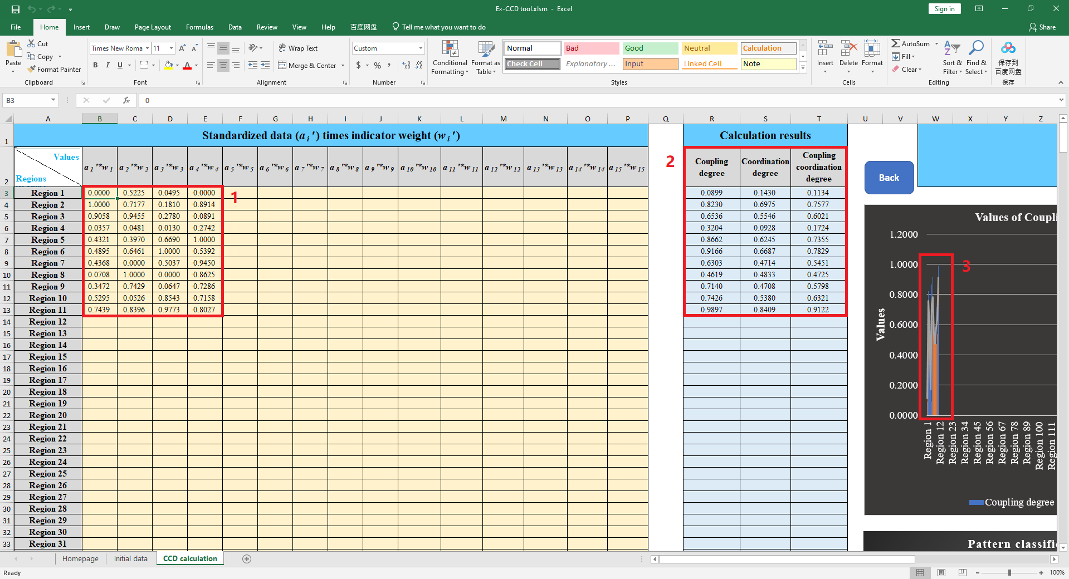

To make the display range of the visualization results more reasonable, the names of the areas need to be pasted in the position shown by "2" in the figure below.

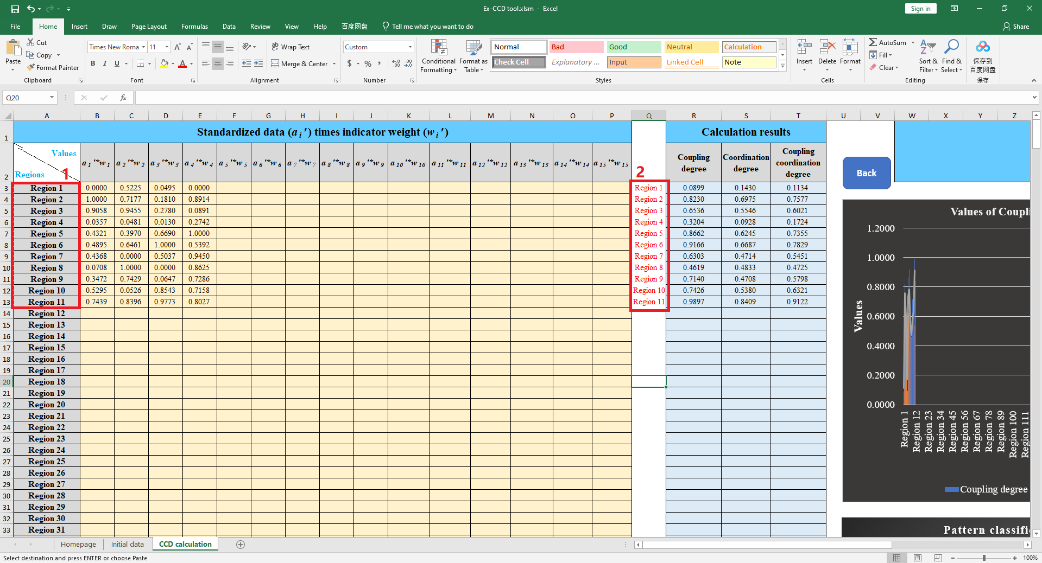

Then, right-click in the black image shown below, and click the "Select data" button.

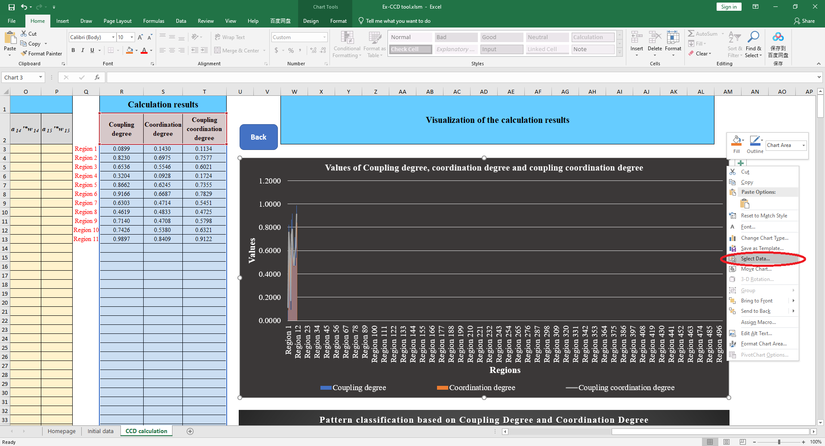

The range of the visualization data will be reselected and the content will be displayed in a red box as shown in the figure below.

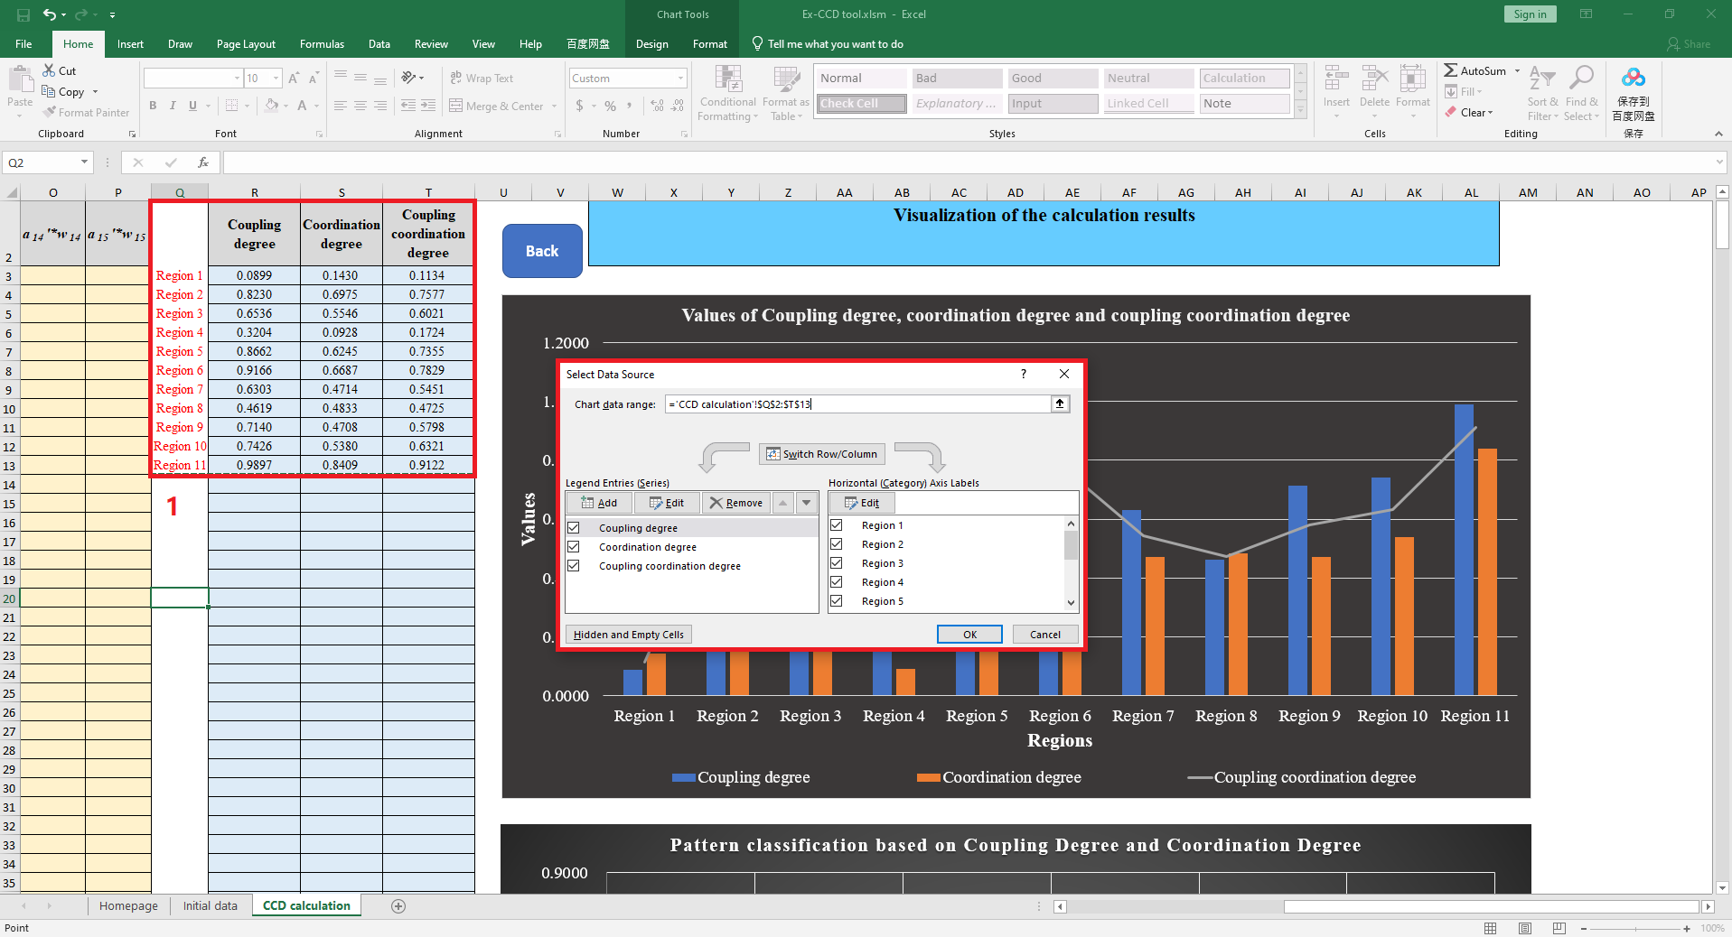

For the following the generation of the scatter plot, the necessary labeling of data points is required.

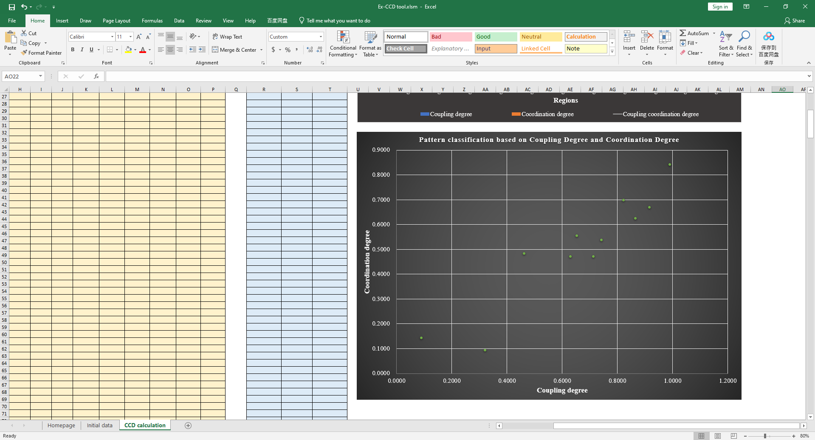

First, click on this picture, and then click the button at "1" in the picture shown below. Next click “Data labels” at “2”, and go to “More Options” at “3”.

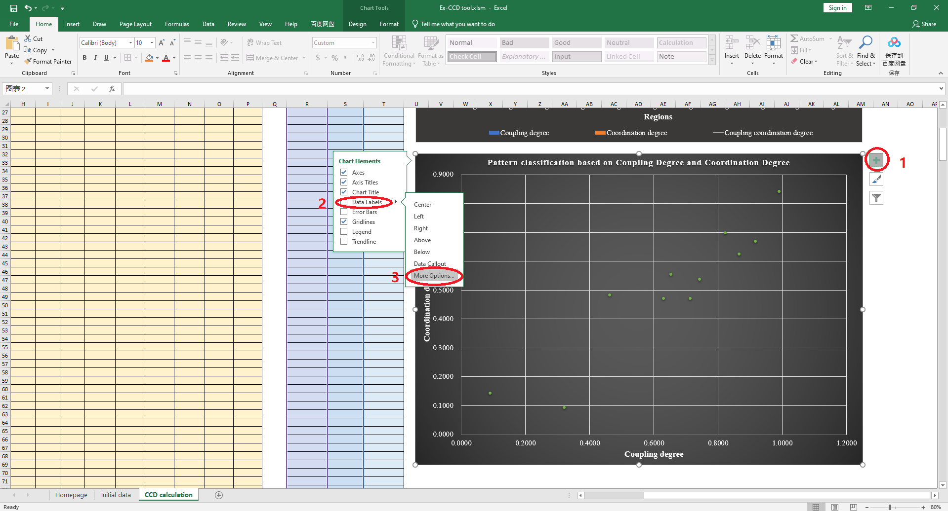

In the red frame shown below, click “Value From Cells”.

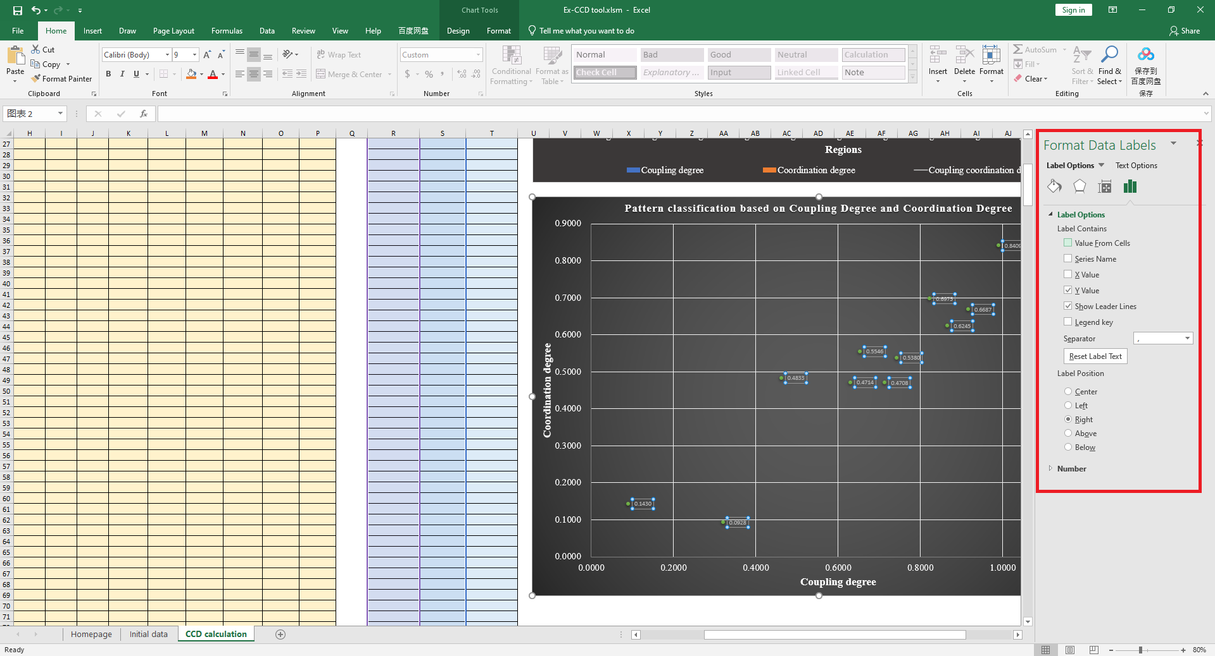

And select the regions in the position “1” shown in the figure below. Then, click “OK” in the Data Label Range box.

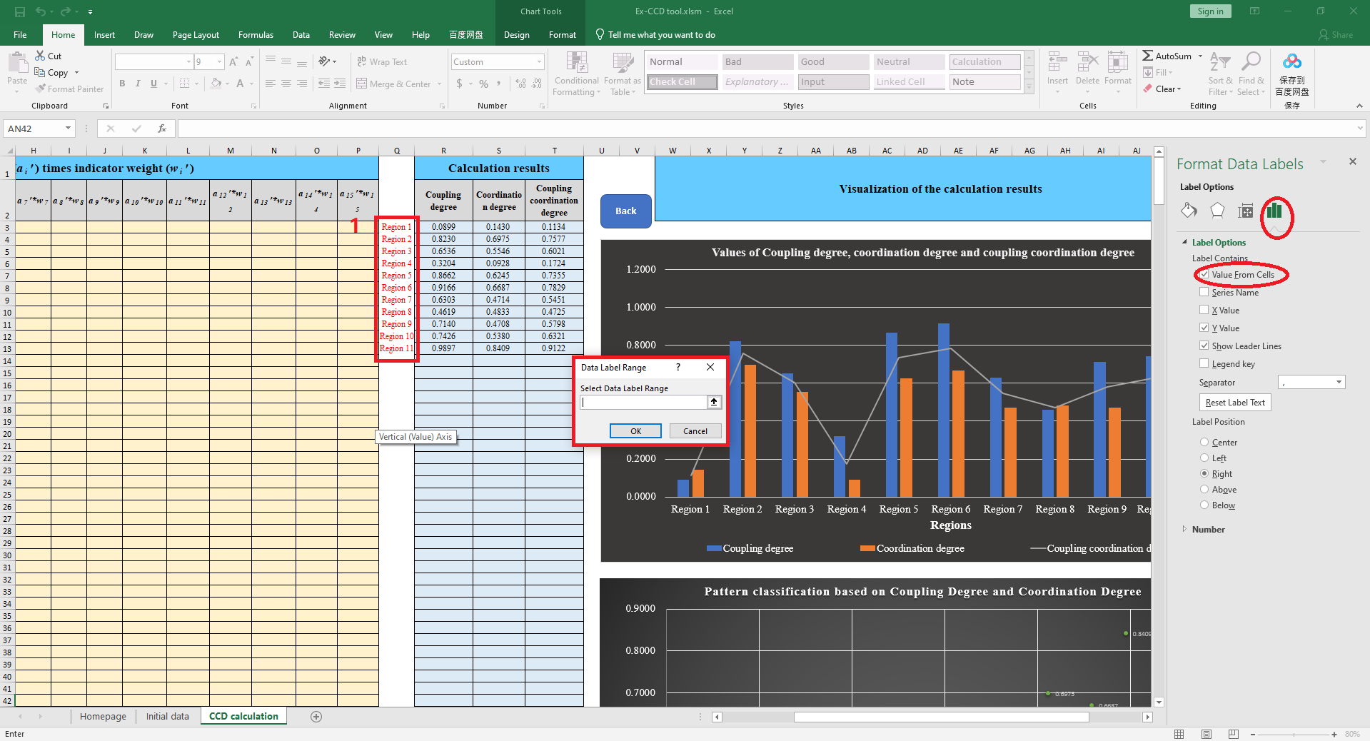

The font can be set as shown in the figure below and the labels are entered in column Q.

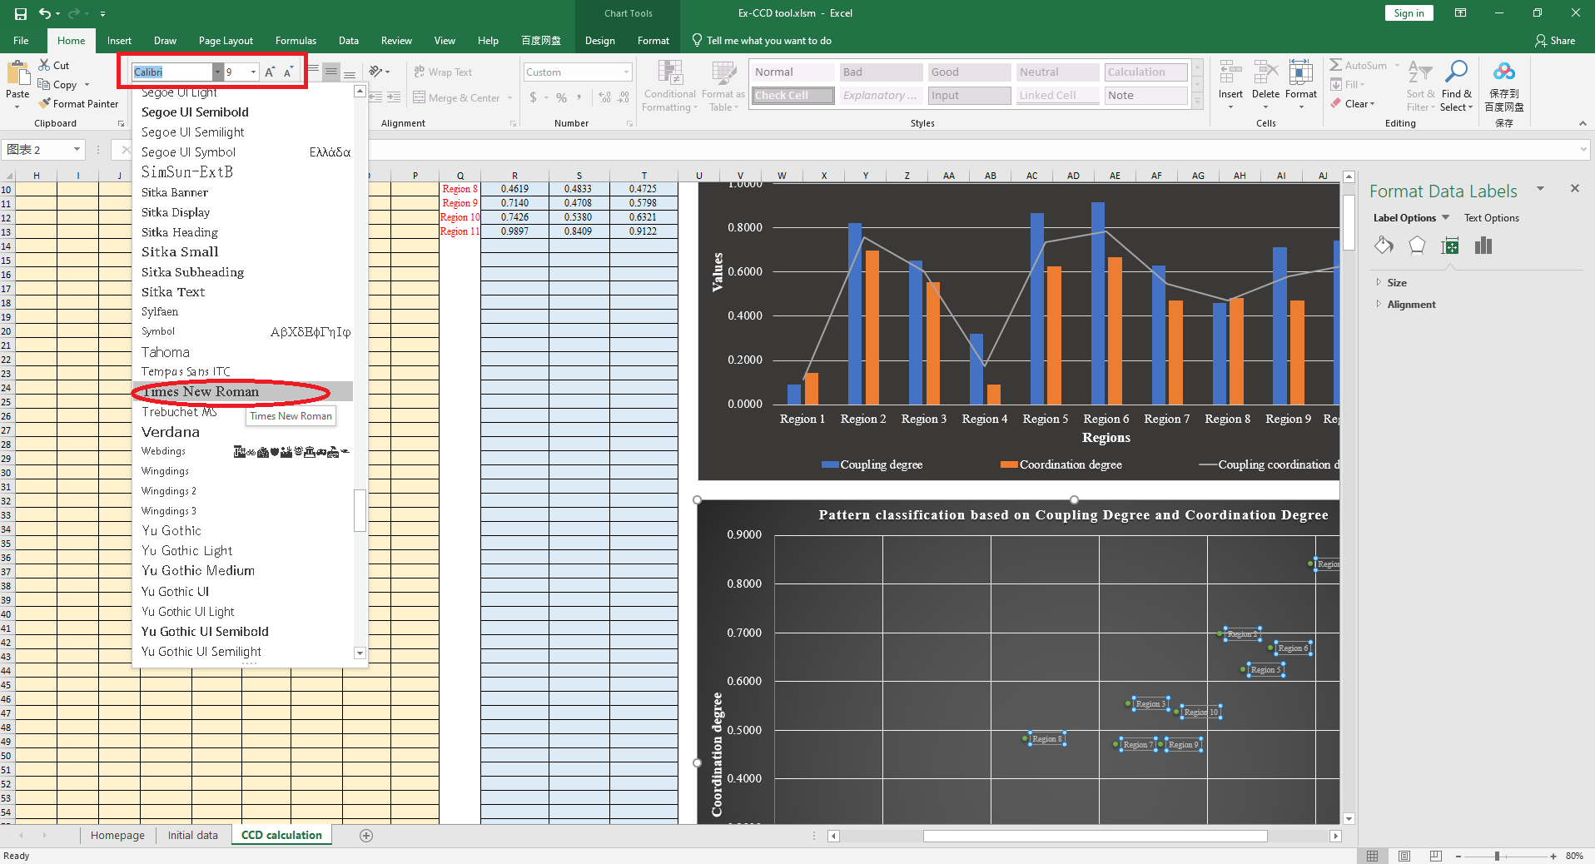

For some time-series data, choosing a line chart can better reflect the trend of CCD changes over time. We assume that the data are for the years 2000-2010. First, you need to place the year data in the red box in the figure below.

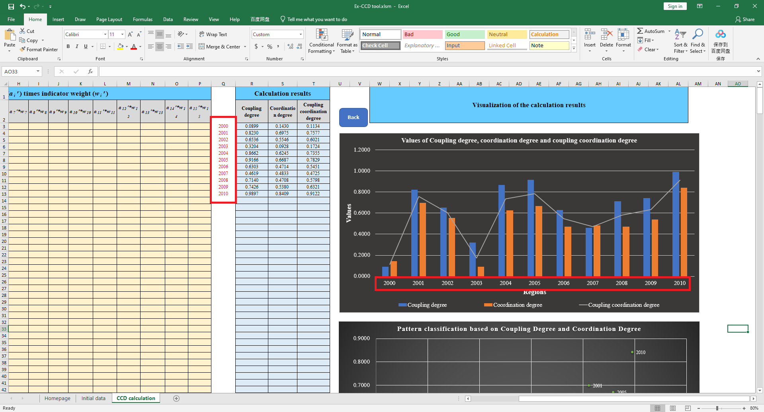

Therefore, for time-series data visualization, click the “Change Chart Type” button as shown in the figure below.

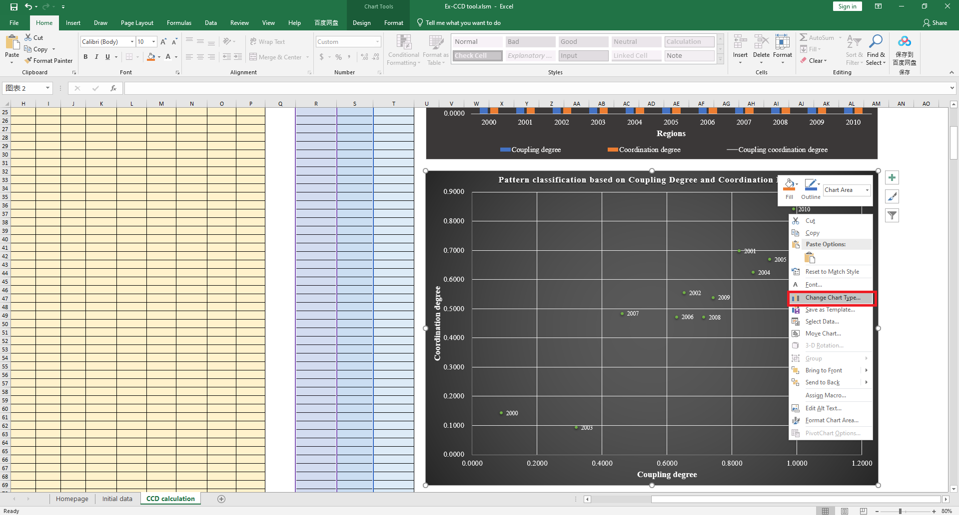

Select “Scatter with Smooth Lines and Markers” in all charts, as shown in the figure below.

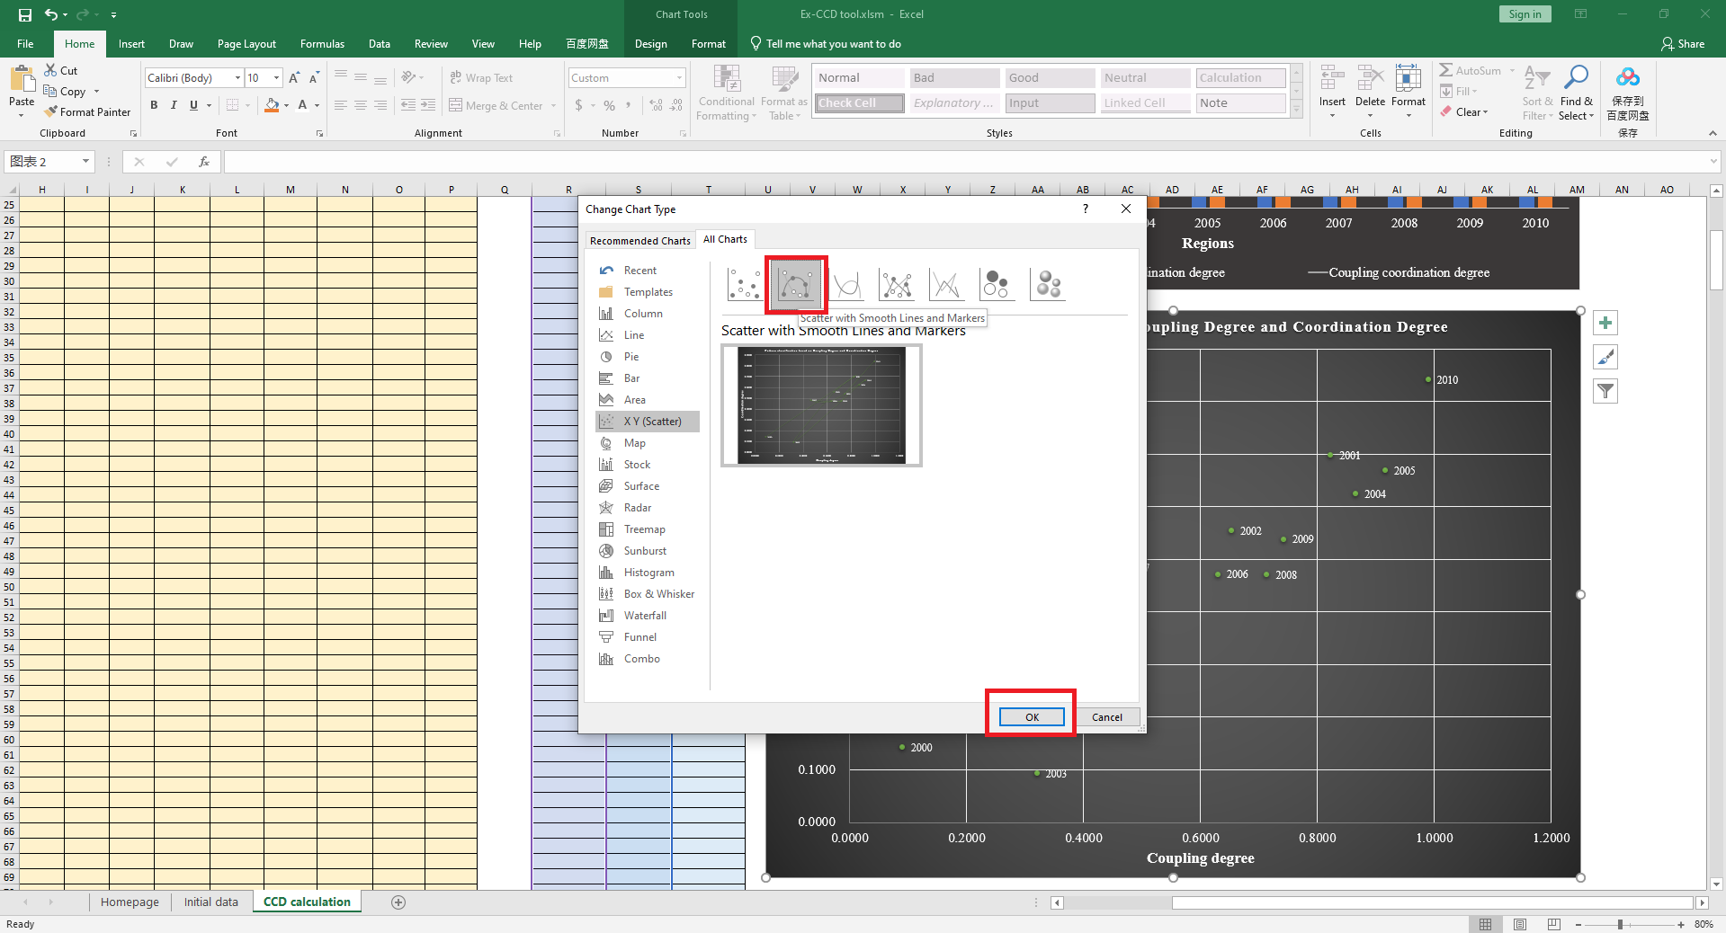

Adjust the line shape using the button in the red box as shown in the figure below.

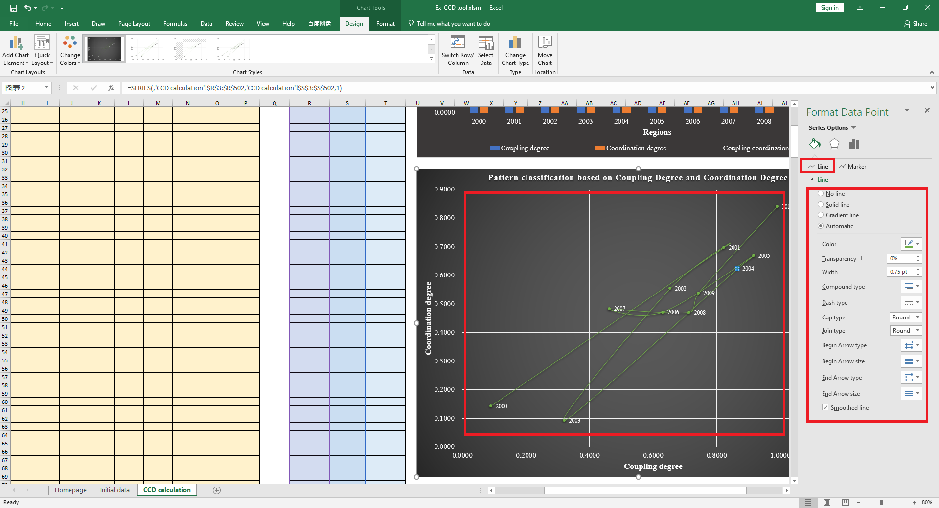

Adjust the Marker from the button in the red box as shown in the figure below.

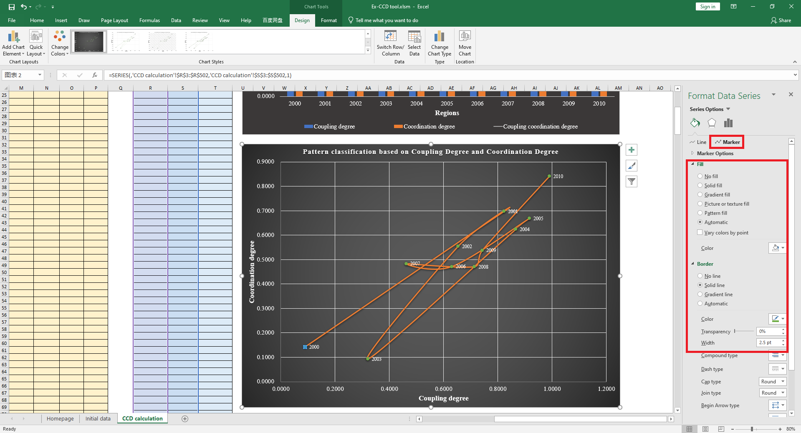

Through the above operations, we have demonstrated the calculation and visualization of the coupling coordination degree by using the EX-CCD tool.

**4. Precautions**

When you click "Element data input" and "Element weight input" again, the previous data will be cleared. Therefore, when you need to use the tool multiple times, you need to pay attention to saving the data.